Media Contact:
Suzanne Gentry Flodin
214.500.4289
Suzanne@thegentryagency.com

FOR IMMEDIATE RELEASE
Dastur Elected Chair of Metrocrest Services Board of Directors
Committed volunteer to lead non-profit board in growth phase for organization, which will include construction of new headquarters

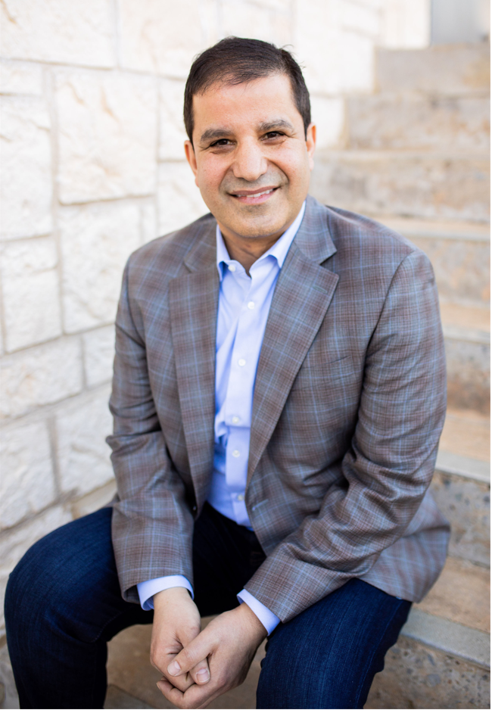
DALLAS/CARROLLTON/ADDISON/FARMERS BRANCH/COPPELL, Texas (Oct. 25, 2021) – Andy Dastur, a committed volunteer and leader of Metrocrest Services, has been elected 2021-2022 chair of the organization’s board of directors. The non-profit organization, which provides programs for individuals, families and seniors that lead to self-sufficiency and foster independence, is celebrating its 50th anniversary in 2021 and embarking upon a growth phase that will include the construction of new headquarters.
“The expertise and commitment of our board is a perfect match for the opportunity we have before us to impact so many,” said Tracy Eubanks, CEO of Metrocrest Services. “Under Andy’s leadership, we will be able to achieve the great things we set out to do, lifting lives and creating opportunity for those we serve.”
Dastur has 30 years of leadership in the health insurance, Medicare and financial services industry including executive experience at Fortune 100 companies such as United HealthCare, Aetna and Transamerica.
As president of North American Insurance Services, Dastur is responsible for leading a major national independent insurance marketing organization. A chartered life underwriter and a certified financial planner, Andy has trained and mentored thousands of successful advisors across the country to share what he has learned with others in the industry. He is called upon frequently to serve as a speaker and subject matter expert at national insurance events, leveraging his industry experience to help educate advisors across the country.
Dastur is a graduate of Texas A&M University, where he received a bachelor’s in finance. He also is a graduate of The University of Texas at Dallas, where he received a master’s in business administration.
Dastur has served as a member of the Metrocrest Services Board of Directors since 2016, and previously served on the board of Senior Adult Services, a non-profit organization.
In addition to his chairman duties on the Metrocrest Services Board of Directors, which began in October, Dastur also serves on the executive, governance and strategic planning committees.
Metrocrest Services celebrated its 50th year of service in 2021, a year when many Metrocrest clients experienced greater need than ever before due to the ongoing pandemic and the deadly winter storm. With demand for assistance with rent, food, utilities, workforce development and other services at a high, Metrocrest Services relies more than ever on the leadership and skill of its board of directors. The non-profit agency is currently in a growth phase, including construction of new headquarters starting in January 2022, and is putting long-term plans in place to enable the organization to serve increased needs well into the next 50 years.
“Andy is a strong and devoted leader who has a true passion for helping others,” Eubanks said. “He is just as comfortable in the food pantry as he is in the board room. Andy volunteers for our Sack Summer Hunger program along with his family, helping to provide meals for children who otherwise might go without during the summer -- and leading his own family by example.”
“It’s both my honor and my privilege to serve in a community that has given my family and me so much,” Dastur said. “Helping keep other families and individuals from experiencing homelessness, hunger, or hopelessness is something anyone can do by being a volunteer with Metrocrest Services. I encourage everyone to join our mission. I’m grateful for the opportunity to contribute to this great organization.”
Dastur leads the 2021-2022 Metrocrest Services Board of Directors:

Andy Dastur, Chair
North American Insurance
Mike Hansen, Secretary
Options Clearing Corporation
Beccy Ratliff, Past Chair
The Ratliff Group, LLC
Jayson Sims, Treasurer
Mobility Credit Union
Aaron Augustine
Allstate Insurance
Dianne Fletcher
Community Volunteer
Kita M. Hobbs
Oncor Electric Delivery
Amy Marhoefer
Southwest Airlines
Bennett McEvoy
Western Extrusions
Shellie Rayford
Citi
Jamie Robertson
PlainsCapital, Frisco Star
Coby Sparks
The J.Renee’ Group
Jack Stotz
Community Volunteer
Lauren Turner
TD Industries
Kristi Valentine
Valentine Premier Construction
Greg Wilcox
Frost Bank

Liaisons
Pat Cochran
City of Carrollton
Linda Braddy
Dallas College – Brookhaven Campus
Anthony Hill
Coppell ISD
Biju Mathew
City of Coppell
Pam Peña
Carrollton-Farmers Branch ISD
Fran Powell
Town of Addison
Cristal Retana
City of Farmers Branch
Judge Chris Lopez
Denton County
Stacy Teague
Lewisville ISD
Lou Sartor
Advisory Council Chair
Advisory Council
Lou Sartor
Advisory Council Chair
Shawn Bhagat
American Energy Distribution
Gary Blanscet
Community Volunteer
Bobby Burns
Community Volunteer
Marvin Franklin
Merrill Lynch
Charles B. Heath
Community Volunteer
Scott Orr
Fidelity Investments
Linda Rutherford
Southwest Airlines
Hooman Sedighi, MD
Physical Medicine Consultants
Susan Watson
Carrollton Regional Medical Center
Mike Whelan
Verity Instruments, Inc.
Ron Whitehead
Community Volunteer
Craig Woodfield
Grant Thornton

Metrocrest Services, Inc., is a 501(c)3 nonprofit organization dedicated to providing programs for individuals, families and seniors that lead to self-sufficiency and foster independence. Programs include rent and utility bill assistance, financial and budgeting assistance, food pantry, employment coaching and transportation, minor home repairs and home-delivered meals to benefit seniors. Additionally, Metrocrest provides programs focused on children including holiday gifts and summer food. For more information, visit www.metrocrestservices.org.
###

