FOR IMMEDIATE RELEASE Media Contact:
Caitlin Hardegree
972.446.2102
chardegree@metrocrestservices.org

Keyholder Breakfast Highlights the Opportunities Created and Lives Lifted by Metrocrest Services
There wasn't a dry eye in the crowd as dozens of current and former clients shared powerful testimonies of hope, resilience, and gratitude.

DALLAS/CARROLLTON/ADDISON/FARMERS BRANCH/COPPELL, Texas (April 7, 2022)– On Tuesday, April 5, 2022, at the 17th Annual Keyholder Breakfast, over 400 community members gathered together to celebrate the work Metrocrest Services does to help North Texans out of crises and on a path to self-sufficiency. The event, held at the Courtyard by Marriott Dallas Carrollton Conference Center, hosted community leaders, donors, volunteers, and dozens of current and former clients. During the breakfast, many clients in attendance shared with event emcee Mike Doocy and the audience the impact Metrocrest Services has on their life.
"The kindness, compassion, and validation I've received from Metrocrest Services has resurrected my hope for the future," said Mary Beth at the breakfast. Mary Beth came to Metrocrest many years ago as a food pantry volunteer. In 2020, she suffered a severe heart attack that forced her into early retirement. Living solely on her social security, she relies on Metrocrest Services food pantry for healthy meals and recently began financial coaching. There wasn't a dry eye in the crowd as clients like Mary Beth expressed their gratitude for the services they received from the organization.
At the breakfast, Metrocrest Services also launched the Opportunities Fund, which allows Metrocrest Services to go above and beyond their regular services to lift the lives of our neighbors in need. In addition, Aaron Augustine, Allstate Insurance Agency, and The Branch Church received the Lou Sartor Heart for the Community Award for their commitment to serving the community.
"This Keyholder Breakfast was truly special," said COO Nicole Binkley. "Hearing the impact the organization has made on so many lives throughout the years reminds us that, together, we can build a thriving community for all."
Metrocrest Services, Inc. is a 501(c)3 nonprofit organization dedicated to providing programs for individuals, families, and seniors that lead to self-sufficiency and foster independence. Programs include rent and utility bill assistance, financial and budgeting assistance, food pantry, employment coaching and transportation, minor home repairs, and home-delivered meals to benefit seniors. Additionally, Metrocrest provides programs focused on children, including holiday gifts and summer food. For more information, visit www.metrocrestservices.org.
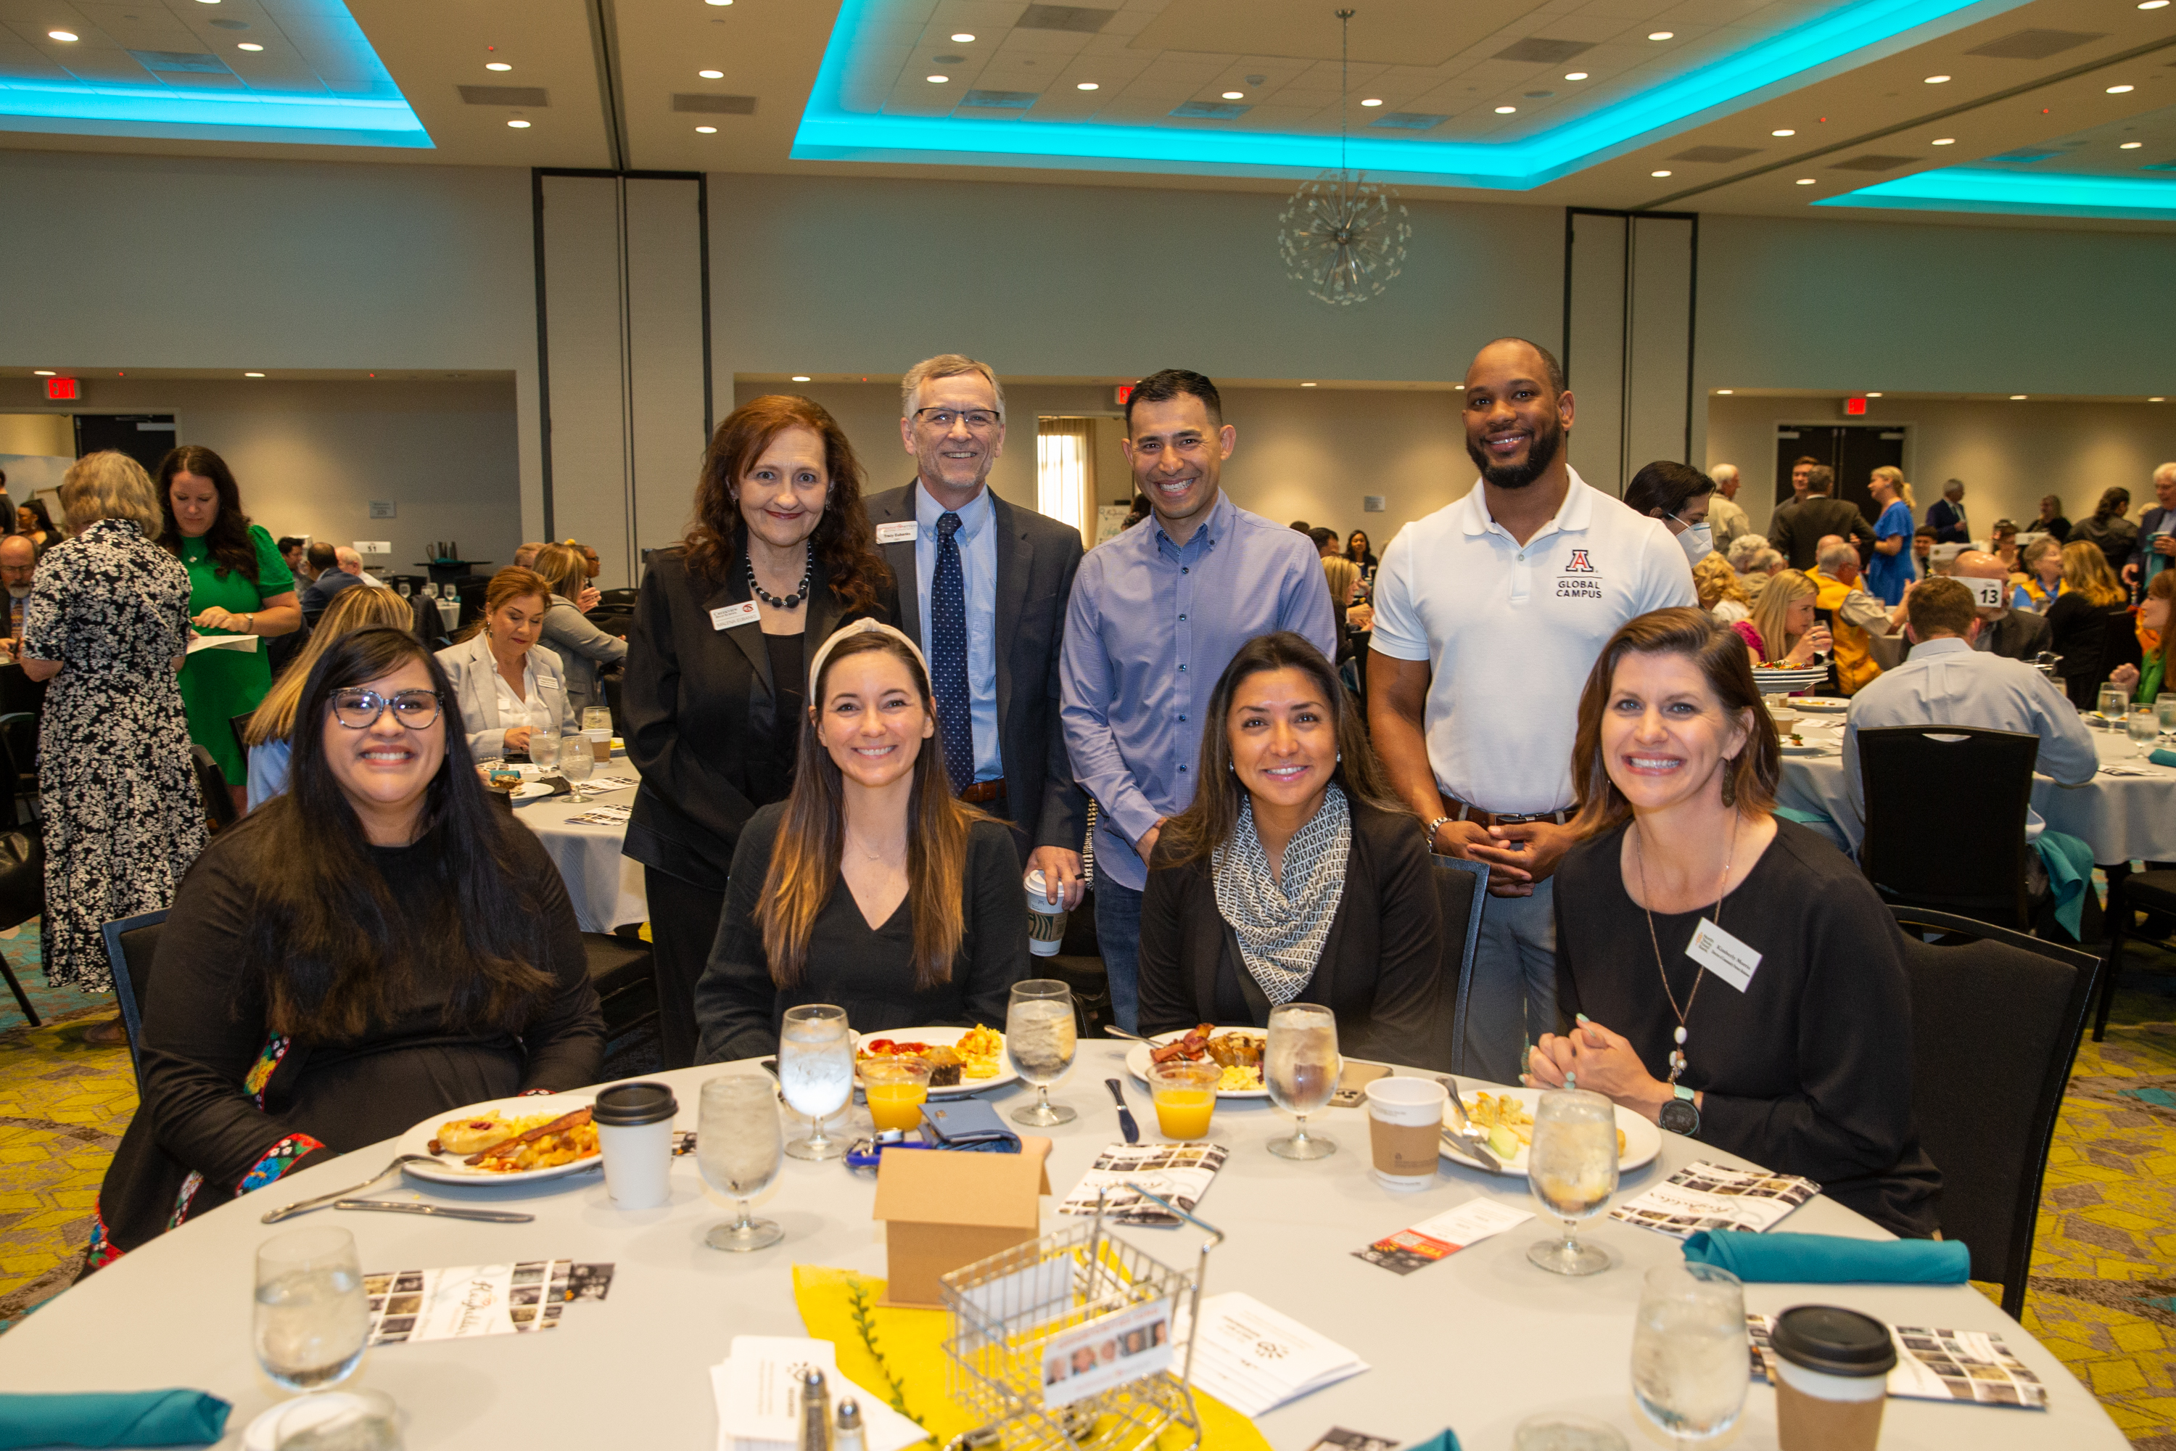
Guests enjoyed a delicious breakfast and powerful testimonials at Metrocrest Services' Keyholder Breakfast. Pictured left to right are Anna Kurian, Malena Eubanks, Danielle Dow, Tracy Eubanks, Jesse Castaneda, Lucy Gore, Shaylor Bernard, and Kimberly Morris.
>>> Click here to view high-resolution photos <<<
###

