FOR IMMEDIATE RELEASE Media Contact:
Caitlin Hardegree
972.446.2102
chardegree@metrocrestservices.org

New Refrigerated Truck Helps Local Food Pantry Feed More People
As the price of gas and groceries continues to rise, so do visits to Food Pantry.

DALLAS/CARROLLTON/ADDISON/FARMERS BRANCH/COPPELL, Texas (June 21, 2022)– On Tuesday, June 7, 2022, Metrocrest Services staff and volunteers celebrated a new refrigerated truck with a ribbon-cutting. The new truck replaced one over ten years old with more than 231,000 city miles.
"You may wonder why we're celebrating a new truck," remarked CEO Tracy Eubanks during the event. "Well, you didn't see the old one!"
The Food Pantry has seen a significant increase in visits over the past few months. "Last month alone, the pantry served 3,822 people, a 47% increase over the previous year," said Claire Brown, Metrocrest Services Food Pantry Manager.
"We've seen a direct correlation in the rise of gas and grocery prices and the number of families visiting our food pantry. This truck will ensure we can continue to feed people without disruption," explained Brown.
Without a truck to transport food from Metrocrest Services' warehouse to their Food Pantry, as well as to pick up healthy food from partner network, Metrocrest Services would be unable to serve local families, seniors, and individuals experiencing food insecurity ─ leaving thousands of people wondering where their next meal would come from.
Last year, Metrocrest Services embarked on the Ride to End Hunger to raise funds for the new refrigerated truck. Most of the funding was secured thanks to the generosity of the North Texas Food Bank and Albertsons. However, the local nonprofit organization still needs to raise $26,407 in community support to pay off the truck. Community members interested in supporting the Ride to End Hunger should contact Development Director Rhonda Ross at rross@metrocrestservices.org or call (972) 446-2100 ext. 164 to learn more.
Metrocrest Services, Inc. is a 501(c)3 nonprofit organization dedicated to providing programs for individuals, families, and seniors that lead to self-sufficiency and foster independence. Programs include rent and utility bill assistance, financial and budgeting assistance, food pantry, employment coaching and transportation, minor home repairs, and home-delivered meals to benefit seniors. Additionally, Metrocrest provides programs focused on children, including holiday gifts and summer food. For more information, visit www.metrocrestservices.org.
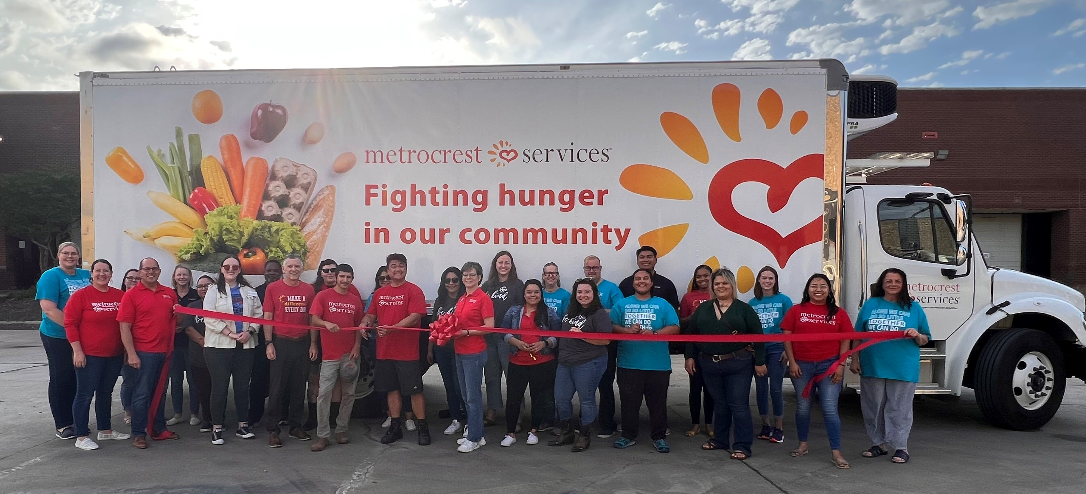
Metrocrest Services staff celebrate new refrigerated truck with a ribbon-cutting.
With the new truck, Metrocrest Services can transport more nutritious food to the Food Pantry, reducing trips and time required to keep the pantry stocked.
>>> Click here to view high-resolution photos <<<
###

