FOR IMMEDIATE RELEASE Media Contact:
Caitlin Hardegree
972.446.2102
chardegree@metrocrestservices.org

Metrocrest Services to Honor "Hidden Heroes" in Community
Inaugural Hidden Heroes Luncheon to recognize community members creating positive change through everyday actions.

DALLAS/CARROLLTON/ADDISON/FARMERS BRANCH/COPPELL, Texas (September 13, 2022)– On Tuesday, November 1, 2022, at the first ever Hidden Heroes Luncheon, Metrocrest Services will honor Jason McCann accepting on behalf of Vari®, The McEvoy Family, Drs. Hooman and Tannaz Sedighi accepting on behalf of MTO Shahmaghsoudi® – School of Islamic Sufism®, and Morgan Merritt as this year’s Hidden Heroes.
"These individuals have been integral in reducing inequities in our community and helping to ensure all residents have access to the resources they need to navigate through crisis situations and stabilize their lives for a brighter future," shares Metrocrest Services CEO Tracy Eubanks. "We're excited to be able to celebrate their efforts."
Jason McCann will accept the Hidden Heroes award on behalf of the entire Vari® team. As CEO and Co-Founder of Vari®, Jason has created a culture that recognizes the importance of making a positive impact in the community. As part of the Vari® Community Giving program, the company has donated more than $6 million worth of furniture in-kind to nonprofit organizations across the country. In addition, Vari® provides paid volunteer time for all employees.
"My team was volunteering before I knew what Metrocrest Services even was," Jason said. "Once I volunteered, I wanted to do more. Metrocrest provides invaluable services to people in our local communities. We have been proud to support their incredible work for several years!"
The McEvoy Family has always understood the importance of helping others. Founder and "Retired Principal" of Western Extrusions, Patrick McEvoy Jr., sits on the board of the Constantin Foundation and has supported nonprofit organizations like Metrocrest Services since 1979. Patrick credits his son, Bennett McEvoy, now CEO of Western Extrusions, for creating a culture of community giving at the company. This year, the company implemented a monthly employee giving program benefiting Metrocrest Services, and Bennett is an active member of Metrocrest Services' Board of Directors.
"Growing up in Carrollton, I didn't realize we had so many people that needed some extra help. The important thing is, with Metrocrest Services, support is there. If we give them the resources, they help people get what they need to become self-sufficient," shares Patrick.
Drs. Hooman & Tannaz Sedighi are accepting the Hidden Heroes award on behalf of the students of MTO Shahmaghsoudi® – School of Islamic Sufism® (MTO), an international nonprofit organization with activities that span a range of community, charitable, and learning initiatives. As supporters of Metrocrest Services and other local nonprofits, the Sedighi's and their fellow MTO students strive to make the community a better place. "We're honored to support the great work at Metrocrest Services," said Hooman.
Morgan Merritt represents the next generation of philanthropists. In first grade, Morgan told her parents that for her birthday, she wanted all her gifts given to "people who needed it more." Morgan, now a senior at Ursuline Academy, has supported Metrocrest Services through volunteerism and in-kind donations since she chose to donate the toys she received at her first-grade birthday party to the organization. In 2020, she began hosting an annual Easter Egg Hunt to raise funds for Metrocrest Services. To date, the event has raised $5,000 for the organization. In addition to her work with Metrocrest Services, Morgan is a member of various student-led clubs, a donor to the Appalachian Service Project, and was an inaugural member of the city of Farmers Branch's Youth Advisory Council.
Morgan credits her dad for inspiring her to help others. "My dad is one of the most selfless people I know," shares Morgan. "He does not think twice about helping others. I strive to be more like him every day."

The Hidden Heroes Luncheon is Tuesday, November 1, 2022, from 11:30 AM to 1:00 PM at The Westin Galleria Dallas. At the event, guests will enjoy fun and festivities with friends, network with community leaders, celebrate this year's Hidden Hero honorees, and browse the Hidden Treasures Boutique, a pop-up store with rare and unique items from the Metrocrest Resale store.
Sponsorships and individual tickets to the Hidden Heroes Luncheon are now available. As one of two annual fundraisers for the organization, proceeds from the event are critical to ensuring Metrocrest Services has the resources needed to help more than 25,000 northern Dallas County and southeastern Denton County residents each year. For more information, visit metrocrestservices.org/beahero/.
Metrocrest Services, Inc. is a 501(c)3 nonprofit organization dedicated to providing programs for individuals, families, and seniors that lead to self-sufficiency and foster independence. Programs include rent and utility bill assistance, financial and budgeting assistance, food pantry, employment coaching and transportation, minor home repairs, and home-delivered meals to benefit seniors. Additionally, Metrocrest provides programs focused on children, including holiday gifts and summer food. For more information, visit metrocrestservices.org.
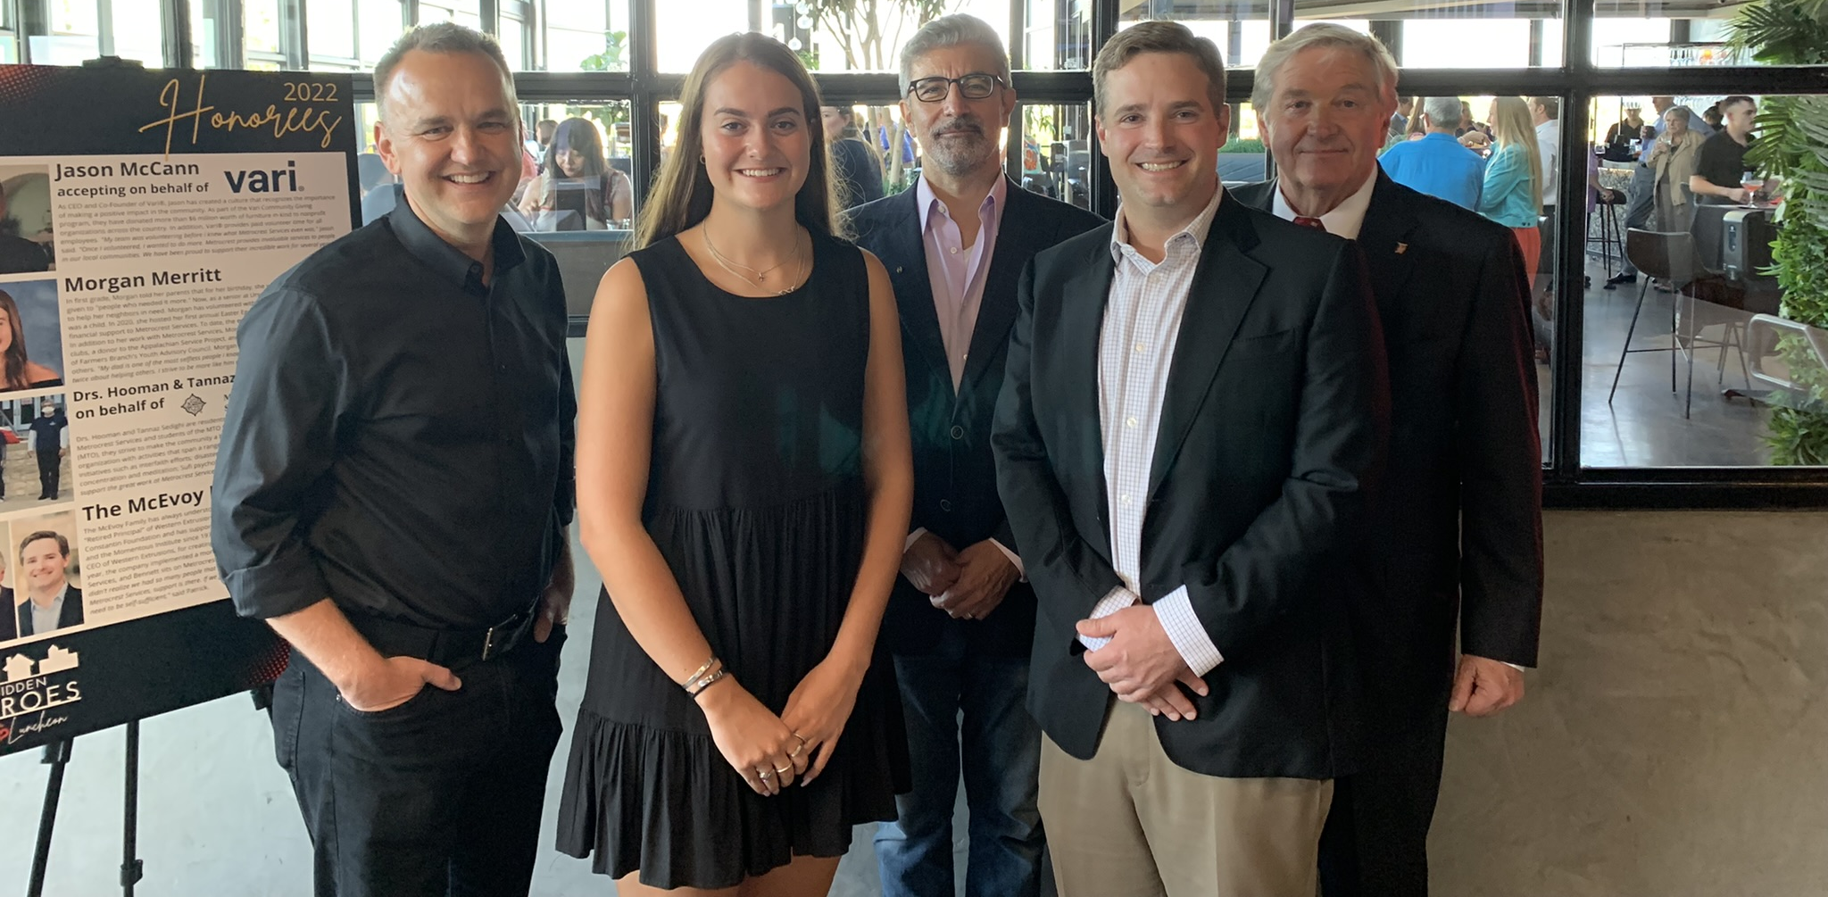
2022 Hidden Heroe Honorees, Jason McCann, Morgan Merritt, Dr. Hooman Sedighi, Bennett McEvoy, and Patrick McEvoy at the Hidden Heroes Reveal Party on Monday, September 12, 2022 at Stirr Addison.
>>> Click here to view high resolution images <<<
###

