FOR IMMEDIATE RELEASE Media Contact:
Caitlin Hardegree
972.446.2102
chardegree@metrocrestservices.org

Holiday Store Helps Parents become the Heroes of the Holidays
Metrocrest Services' annual holiday store offers parents with limited incomes the opportunity to create a magical holiday season for their children.

DALLAS/CARROLLTON/ADDISON/FARMERS BRANCH/COPPELL, Texas (December 9, 2022)– No parent should have to choose between covering the cost of the electric bill and putting gifts under the tree. That's why Metrocrest Services hosts its annual holiday store, staffed by volunteers and supplied by generous North Texans.
Metrocrest Services anticipates serving 1,100+ families and over 2,500 children through the 2022 Holiday store (open December 10 – December 20). "High prices and inflation have affected our neighbors' ability to buy gifts for their children," shares Chief Operating Officer Nicole Binkley. "Right now, 58% of families signed up for the Holiday Program have never used our services before."
"The Metrocrest Services' holiday store allows parents the opportunity to be the heroes of the holidays by empowering them to select toys and holiday décor, helping bring the magic of the holiday season into their homes," notes Binkley. Once registered, parents choose an appointment time to visit the store and pick out gifts for their children, winter coats for the entire family, nonperishable food, stocking stuffers, gift wrap, and (if needed) even a Christmas tree.
"I'm so thankful Metrocrest helped me find the perfect present for my sons," shares a mom while expressing her gratitude to the community for helping put gifts under the tree this Christmas.
"This event truly is a community effort," explains Binkley. "From the volunteers who staff the store to the donors who provide toys, coats, and food, the holiday store reminds us all that giving is alive and well in North Texas."
How to help? Go to https://metrocrestservices.org/ways-to-give-this-holiday-season/ to learn how easy it is to support local families this holiday season.
"Right now, we're concerned about having enough books for all ages and gifts for children ages 8 - 10 years," shares Binkley. "As you shop for the little ones in your life, consider adding an extra gift (or two) to your shopping cart for a child whose loved ones cannot afford to buy them gifts this year. I know the families we serve will appreciate your support."
Metrocrest Services, Inc. is a 501(c)3 nonprofit organization dedicated to providing programs for individuals, families, and seniors that lead to self-sufficiency and foster independence. Programs include rent and utility bill assistance, financial and budgeting assistance, food pantry, employment coaching and transportation, minor home repairs, and home-delivered meals to benefit seniors. Additionally, Metrocrest provides programs focused on children, including holiday gifts and summer food. For more information, visit www.metrocrestservices.org.
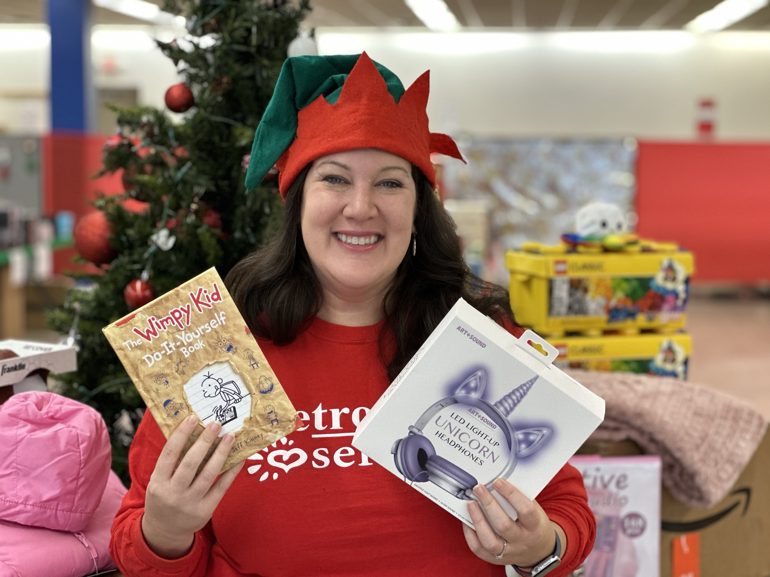
Metrocrest COO Nicole Binkley with items donated to the Metrocrest Services holiday store
>>>Click here to view high-resolution images<<<
###

