Media Contacts:

Suzanne Gentry Flodin Caitlin Hardegree

The Gentry Agency Metrocrest Services

214-500-4289 972-446-2102

[suzanne@gentry.agency](mailto:suzanne@gentry.agency) [chardegree@metrocrestservices.org](mailto:chardegree@metrocrestservices.org)

FOR IMMEDIATE RELEASE

**Non-profit Veteran Calvin Moore Tapped as COO of Metrocrest Services**

*Longtime, mission-oriented leader committed to providing services that*

*empower individuals to lead independent lives*

DALLAS/CARROLLTON/ADDISON/FARMERS BRANCH/COPPELL, Texas (August XX, 2024) – Calvin Moore, an experienced non-profit leader with a heart for serving others, has been named chief operating officer for Metrocrest Services, the award-winning social services agency on a mission to provide hope through programs that lead to self-sufficiency and foster independence.

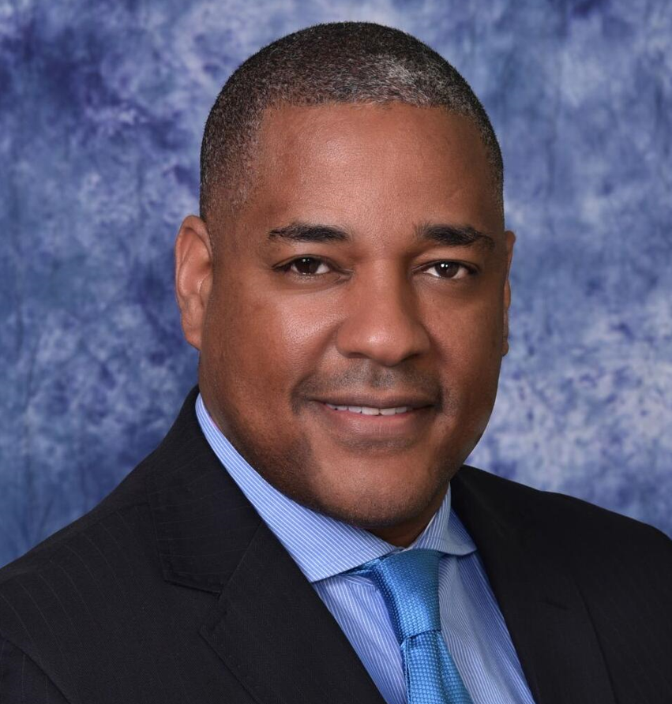Moore is honored to serve alongside the committed professionals and volunteers of Metrocrest Services in his new role as COO, which he began August 26.

“The opportunity to work directly with programs that impact people’s lives is what attracted me to Metrocrest Services,” Moore noted. “My role as COO is to empower the great team that’s already in place, coming alongside of them to enhance their work through operations and programming, serving as a sounding board and providing leadership. Together, we will find new ways to innovate, meeting a need that grows every day.”

Moore, a Gulf Coast native, grew up on a farm in Mississippi, helping his family raise horses, grow their own food and sustain the family timber business. He attended University of Southern Mississippi, graduating with a bachelor’s in political science. He continued his education at Oral Roberts University in Tulsa, earning a master's in finance and business administration with a concentration in non-profit management, as well as a master’s of divinity in theology. Moore also has served his country as a soldier in the U.S. Army Reserves, specializing in both heavy construction and military intelligence.

"I always knew I wanted to spend my life in service to others," Moore said.

Professionally, Moore has a demonstrated history of advancing organizations as a dynamic and purposeful executive with experience in strategic leadership and growth. Previously, he has served as CEO of Food Bank of Eastern Oklahoma, president and CEO of Meals on Wheels of Metro Tulsa, director of Tulsa Community College Foundation and development director of Oral Roberts University.

"Adding Calvin Moore to our team will help us meet the challenges of today and tomorrow, bringing our community together to help those who need the assistance and empowerment that Metrocrest Services provides,” said Tracy Eubanks, CEO of Metrocrest Services. “We are pleased to welcome Calvin to our team, and look forward to many exciting new initiatives we will all accomplish together."

Moore is now a resident of Carrollton, where he lives with his wife, Tangelia Sinclair Moore, a licensed therapist, who previously has worked in young adult ministry. The couple was married in Carrollton in 2000, and has fond memories of the community. Their daughter, Jessecca, is serving in the U.S. Air Force.

Outside of his professional pursuits, Moore is an outdoor enthusiast who enjoys hiking, camping, fishing, snowboarding and chess. He is also a big fan of movies and loves to travel.

Metrocrest Services promotes well-being and independence through programs for individuals, families and seniors that lead to self-sufficiency and foster independence. In 2023, to serve the growing need for services, Metrocrest Services opened its new home in the heart of Carrollton, at Belt Line Road and Josey Lane. Today, the 48,000-square-foot facility is a welcoming hub for all of the agency’s daily operations, including providing access to nutritious food, homeless outreach services, workforce development and financial literacy, rent and utility assistance, senior services and other programs for individuals, families and seniors that lead to self-sufficiency and foster independence. The campus also includes shared space for complementary service providers to support clients from one central location and a volunteer center offering greater access to opportunities for community engagement.

Founded in 1971, **Metrocrest Services, Inc.,** is dedicated to helping individuals, families and seniors navigate crisis situations and guide them on a path to self-sufficiency. To accomplish this, Metrocrest Services offers a wide range of services, starting with those that meet basic needs, including access to nutritious food, resources for homelessness, and short-term financial assistance. Other Metrocrest Services programs focus on helping clients build long-term economic stability through financial education workshops and employment coaching. In addition, Metrocrest Services is committed to enhancing well-being through nutrition education and healthcare guidance, and by providing specialized services to help seniors age in place with dignity and comfort. Seasonal Metrocrest Services programs include holiday gifting for families in need and for seniors to help them share in the joy of the season, and programs that address families’ additional food access needs during summer break from school. From its headquarters at 1145 N. Josey Lane in Carrollton, the award-winning non-profit agency services clients in the Metrocrest areas of Carrollton, Addison, Farmers Branch, Coppell, and residents of Dallas who live in Denton County (75287). Metrocrest Services, Inc. is dedicated to empowering individuals and families to overcome challenges and build a better future. For more information about our programs and how you can support our mission, please visit [metrocrestservices.org](http://www.metrocrestservices.org/) or call 972.446.2100.

###